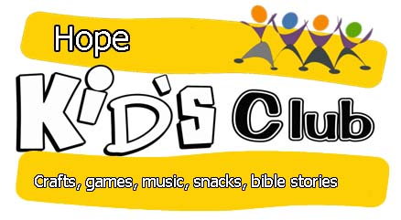Monday 21st November 2016 9.00 to 3.00pm
REGISTRATION FORM
INSIDE-OUT is a free In-Service Day club run by Hope Church Blackwood & Kirkmuirhill,
supported by 2cytrust (Clydesdale Christian Youth Trust). It will take place at Hope Hub, Blackwood on Monday 21st November 2016 from 9:00am to 3:00pm. (Lunch will be provided)
All primary school children are welcome. There will be the usual mix of crafts, games, quizzes and Bible stories.
To assist our planning, please return to 4 Heathfield Drive, Blackwood or send to inserviceclub@hope-free.church by Monday 14th November 2016.

Child’s full name (Please use a separate form for each child.) | Sex: M/F
Date of birth | School
Please register my child (you can enter a familiar name here if your child prefers it) Parent’s/Guardian’s signature
…………………………………………....…………………...
Parent’s/Guardian’s full name
Address
Phone number
I give permission for my child’s and my details to be entered on the church database. YES/NO
I also give consent for my child to be photographed during the club and agree that the photographs may be displayed in the local press and church and 2CYTrust website. YES/NO

Emergency contact name

Phone number
GP’s name GP’s phone number
Any known allergies, conditions or special dietary requirements:
I confirm that the above details are complete and correct to the best of my knowledge.
In the unlikely event of illness or accident, I give permission for any appropriate first aid to be given by the nominated first-aider. In an emergency, and if I cannot be contacted, I am willing for my child to be given hospital treatment, including anaesthetic if necessary. I understand that every effort will be made to contact me as soon as possible.
Signature of Parent/Guardian: Date:

